Executive Summary to Investment Opportuntity and Business Plan

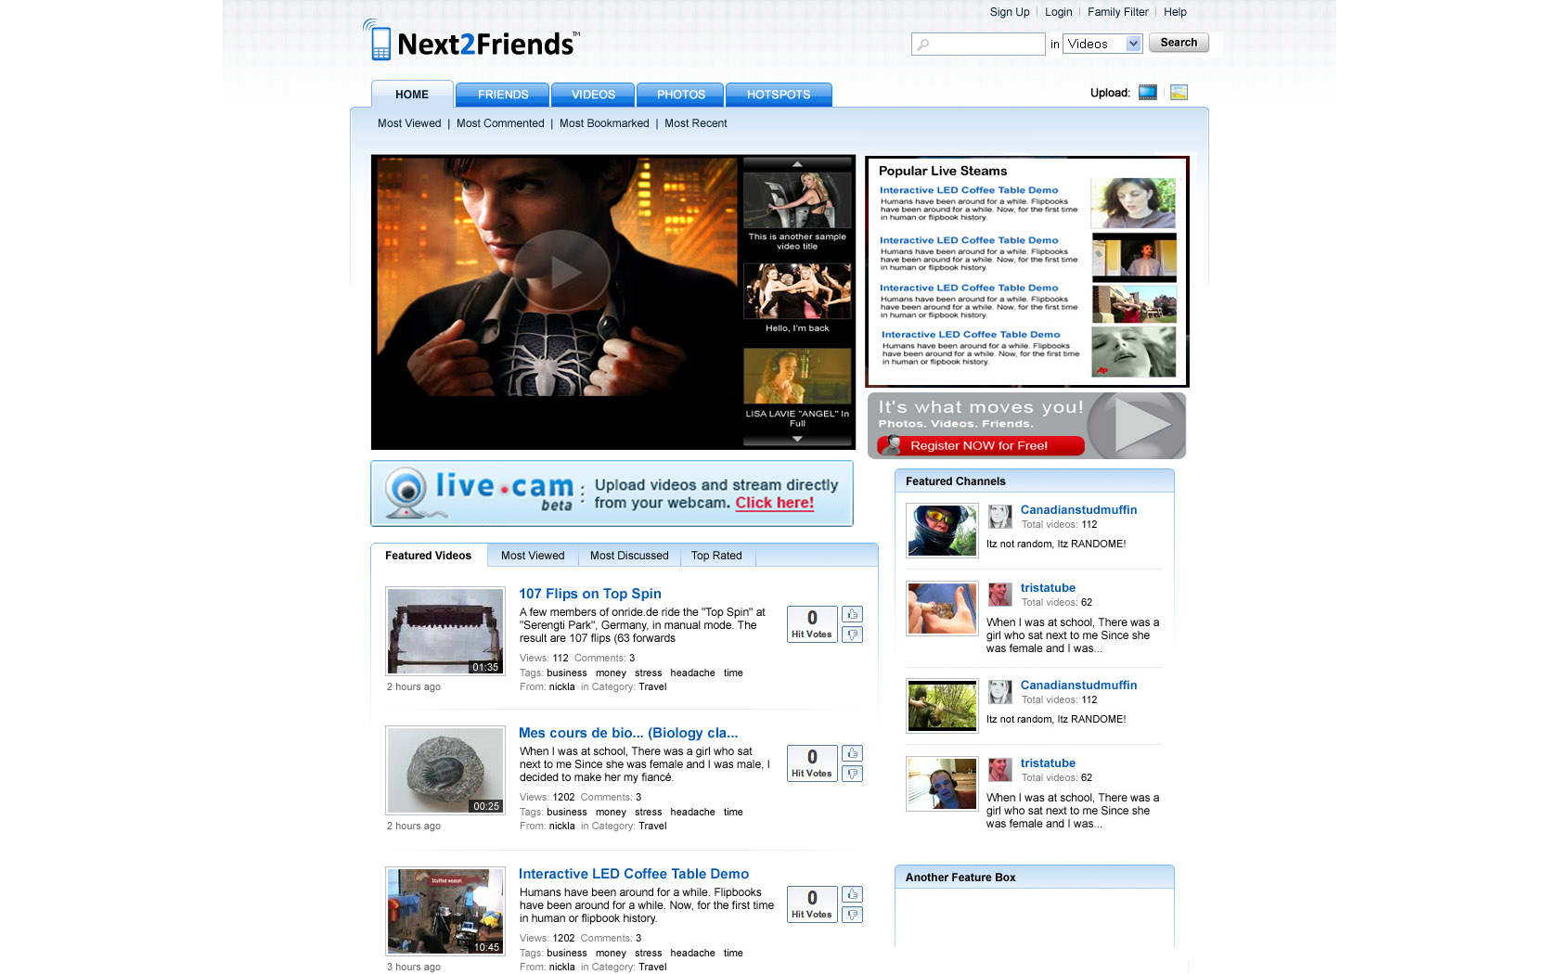

October 2007

Executive Summary

Next2Friends is set to become one of the internets largest companies because it is a significant and incredibly important evolvement of Social Networking. Until now Social Networking has been primarily internet based. Next2Friends offers a revolutionary approach by enabling Social Networking on the world’s most ubiquitous technology – the mobile device. This is achieved by utilizing the Bluetooth stack of the device. Our software is downloaded and delivered to the user’s device as easily as a ring tone. The application of Social Networking using Bluetooth in this manner is a world leading approach and has already been protected by a patent application.

There are other incredibly compelling applications of this technology such as multiple live stream video over Bluetooth and polling over Bluetooth, WiFi or GPRS which we cover later in this Executive Summary. Our research indicated that our target market will eagerly adopt these applications, consolidating Next2Friends as the premier Mobile Social Networking Site. One of the key aspects of enabling Social Networking in mobile devices in this manner is that a user’s mobile device becomes a Self Propagating Intelligent Social Network (SPIN™). This is the perfect and seamless blend of Mobile and Internet technologies and will enable Next2Friends to capitalise upon and outperform proven successes such as YouTube, MySpace, Facebook, LinkedIn,Yowie and Zaiku etc.

Using our technology and our platform Next2Friends users can;;

- Build and potentially meet a network of friends based on intelligent proximity based matching of their profiles along with receiving profile. Next2Friend’s mobile matching system improves on existing social networking by creating a fun and interactive way of meeting people who live and work the same area. The system creates a more personal way of meeting new people than the traditional method of searching large databases of members using keywords and locality options. This is in real time in my environment rather than in cybertime in cyberspace

- Send a request to their network on any item on which they would like to have a poll. This service is called AskaFriend and could be used by a young girl shopping who cannot make up her mind as to which outfit she looks best in. She could take images of several items and create an instant poll among her Next2Friends network who will instantaneously be notified of her request as to which one looks best on her. While waiting for her poll response she will be delivered a sponsored add

- Shoot and simultaneously upload muitl angle/streams rich media such as video and audio in real-time over WiFi, 3G or GPRS to the next2friends platform and then again in real-time share this output with friends remotely. The rich media can be stored and edited on line, viewed by the entire Next2Friends user base (similar to YouTube) or restricted to an individual subscriber’s own network of contacts (similar to Facebook).

Never before has anyone really merged the explosive demand of the online world of social networking with the mobile world. Next2Friends has the technology to exploit this gap and create the most feature rich converged enviroment available worldwide.

So let’s address four basic questions;

- What makes Next2friends so special and how do we differentiate our offering?

By enabling creation of a Social Network on Mobile Devices we move network building into ‘My Immediate World’ as opposed to the ‘Whole Wide World’. This creates relevance for the user in contacts made that has never been delivered before. The free to use version of this software is likely to reach levels exceeding that of Facebook, Linkedin or MySpace. The value add services will also be readily taken up by a significant proportion of the IT literate target market.

From a commercial perspectiveNext2Friends has several unique and major revenue generation lines of product offering, each with a compelling value proposition, these are;

      - Intelligent Matching from Virtual to Reality
        - Enables you to meet people with commons interests who meet your profile and who actually want to meet with you, within just 600 meters rather than thousands of miles away. By using Bluetooth proximity matching you will stand a far greater chance to meet the people you wish to meet where, when and how you want to meet them.
      - Ask-a-Friend
    - When you just cant make up your mind about something wouldn’t it be great to be able to Ask-a Friend. With Next2Friends you can do that and more because you can in an instant (3 key strokes) ask all your friends (or the whole Next2Friends community come to that) what you want to know directly from your mobile and immediately receive the response of all of them in a format that is meaningful and useful to you. Enabling you to make that decision be it fun, serious or just plain whacky one.
      - Internet → Mobile → Mobile Blogging → Live Broadcasting Network
        - How many times have you missed an important family event, or wanted to share that special moment with close friends who cannot be with you right at that moment. With Next2friends real-time rich media (video and voice) stream, you can record and upload that special event via your mobile phone to your chosen family and friends wherever they are in the world. They watch that special moment on line in real-time with you and they can also edit, download or burn a DVD of the event at your own leisure.
      - Revenue Generation for Users
        - Next2friend believes that loyalty is a key element in any ongoing relationship and we are prepared to reward our users for their long term use and for inviting their special friends to join the Next2friends revolution.
      - Demographic/ Rules Based Revenue Generation Advertising
        - So we know you like Sushi from your register profile! How would you like to know where the best sushi house is within a 1km range from your real-time location? Next2friends can help you find the things you want and also enable those businesses promote their goods and services at that moment to a highly target demographic that are actually interested in listening. Increasing market effectiveness for business and to help the users find exactly what they want.

- How will Next2friends attract the level of Subscribers needed to become a success?

Following almost 3 years of extensive research and development Next2Freinds will now launch their Beta service on 25th December 2007. The Beta will run for a period of 3 months. The objectives of the Beta are;

      - Prove we can generate traffic and interest to the site ( www.next2Friends.com) Currently we are generating + 25,000 hits per day with currently one new registration for the service every 90 seconds

      - Prove our Patent Pending Technology is robust, scaleable and user friendly

      - Provide the service free of charge to early adopters and all those who have pre-registered (we expect have in excess of 50,000 pre registered subscribers by Beta launch). After the Beta the service will be free of charge only in a limited format – e.g a maximum of 50-100 users in your network. To extend your network or to take advantage of the other service such as Ask-a Friend or Live Video Streaming you will have to pay a charge. The charge will be relative to the level of functionality you require but will top out at $20 per month. There will be the opportunity to reduce your monthly charge by attracting other users to the network from which you will share in the monthly subscription.
In order to generate increased level of traffic to the next2friends platform pre and post Beta the marketing team of Next2Friends will be targeting the estimated 500,000,000 of mobile subscribers which by 2010 will spend in excess of $27 billion on social network and mobile video services. N2F redefines how a social network is used and therefore we need to ensure our marketing and subscriber acquisition strategy is both realistic and achievable. Our internal draft marketing plan is attached for your review and will consist of as a minimum;
- The Next2Friend’s marketing team will continue to produce and virally promote monthly competitions for such things such as;

  - A free laptop, Ipod or Satellite Navigation system for the Next2Friend’s Subscriber with then Fastest Growing or Largest Paying Subscription network per month
  - $1,000 for the best Spot the Celebrity video as voted by an independent panel or Next2Friends Subscribers
  - $1,000 for the best short 3 minute music or drama video uploaded per month as voted by an independent panel or Next2Friends Subscribers

- The Next2Friend’s marketing team will continue to produce buzz PR which will be virally promoted on a daily basis via high traffic sites and Blogs which are synonymous with our target market. Search engine manipulation and key/ ad words will also form a basis the ongoing hunt for subscribers and brand building.

- Found a user referral program (Member Gets Member) which will allow users earn from their efforts to expand our network. We now have 1000’s of users pre registered for the commercial launch of Next2Friends in order to gain the greater earnings and also capture those first and valuable cult screen names.

- We will build brand awareness with cool low cost and environmentally friendly merchandising such as fair trade t-shirts, caps and biodegradable stickers, all of which will carry the Next2Friends logo. (E.g. Sticking them up in places such as the major metro/underground networks throughout our target market regions)

- Next2Friends’ field based Business Development Managers will manage channel relationships with major wireless operators worldwide. We have already had expressions of strong interest from several large operators in pre-loading the Next2Friends smart application on to their mobile handsets and also being able to allow Subscribers to download the application from their website. The benefit to the operators is the potential increase in content and data revenues plus a small revenue base share from Next2Friends. The benefit to Next2Friends is the increased captive audience to target with the help of large brand affiliation. Please also refer to the draft sales strategy attached.

- Next2Friends will have a number of freelance ‘Hit Squads’ which will attend (gatecrash) key events such as the Tour de France, Glastonbury and Live Aid with a view to mass market attraction such as giving away water bottles by body painted models baring the Next2Friends logo.

- How will Next2Friends make money and quickly become cashflow positive?

The current management team will continue to fund the pre and post beta periods and day to day costs of the current cost based on the current business structure until a suitable investment proposal is received and accepted. A number of regional, institutional and private investors have shown strong interest in making an equity investment for the full $1m capital requirement. The Next2friends cost base is lean and will remain so with an estimated maximum of only 27 people at the peak of their headcount

Next2Friends’ revenue model and growth forecasts are conservatively forecast as;

    - Year 1 110,000 Paying Subscribers with $ 3.4m gross revenues
    - Year 2 230,000 Paying Subscribers with $ 21m gross revenues
    - Year 3 340,000 Paying Subscribers with $ 52m gross revenues

- How Next2friends will retain subscribers and create a sustainable business.

N2F recognises that to have a sustainable business we need to ensure that we retain a high percentage of existing subscribers and attract new ones. There are several proven ‘sticky’ methods and we will use these with our subscribers. These models will be implement pre beta, in-beta and post-beta (Production Live) and will be part of the Next2Friends marketing strategy. The following is an illustrative but not exhaustive list of how we plan to develop and maintain loyalty and income;

- Rewarding subscribers based on the level of connections they attract and allowing them to share in their directly connected friend’s subscription fees each month

- Pay per view advertising revenue from the rich media which is viewed via the next2friends platform. In subsidised categories Next2Friends will pay users $0.05c every time their video has been viewed or downloaded where it contained an advertisement. Next2Friends will charge the advertiser up to $0.20c per download and or viewing in addition to the nominal month fee of between $100-500 per month, which would be dependant upon category required and budget of the advertiser.

Next2Friends Background and Management Team

Next2Friends is a UK Limited Company (formed in 2007) in a pre launch/ pre revenue state with 1000’s of registered users wanting to start and enjoy the benefits of the Next2Friends’ platform. The business needs to find a permanent home and is considering a variety of locations throughout the UK in order to gain maximum support and assistance from regional initiatives.

Knowing that the technology and concept are market leading and that the timing for launch is now appropriate we recognise that to guarantee success we needed to have a top flight, ambitious and extremely committed senior management team. This team consisting of; Roy Shelton, Andrew Doyle, Anthony & Gary Nystrom and Lawrence Botley is now in place. Detailed resumes of all are available as appendices to the business plan We have also already identified several key mid management people who we intend to bring on board as soon as funding is in place and the business requires them.

